Installed to c:\notprogram files\MySQL Server 5.0
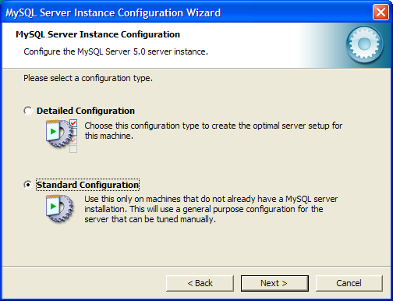

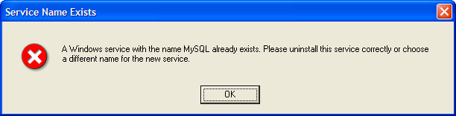

This means I have installed a service called “MySQL”, so I used “MySQL5.0”
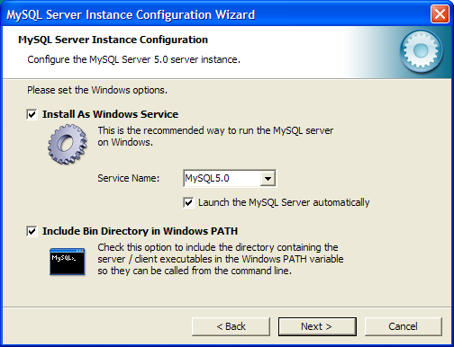
The password is “abcd6789” in the following screen: no Anonymous account
